**MODULE 2**

**1.What is role of client?**

🡺Clients have a major role to play in the promotion of a systematic approach to the management of health and safety in construction. They will set the tone of the project and make decisions crucial to its development.

**2. What is role of server?**

🡺Patch Manager consists of three server roles: Primary Application Server (PAS), Management Server, and Automation Server. By default, all Patch Manager servers include the Automation Server role. When you deploy additional Patch Manager servers, you can deploy just an Automation Server role, or add one or both remaining roles. All Patch Manager servers require separate SQL Server instances.

**3. What is client server architecture?**

🡺architecture of a computer network in which many clients (remote processors) request and receive service from a centralized server (host computer). Client computers provide an interface to allow a computer user to request services of the server and to display the results the server returns.

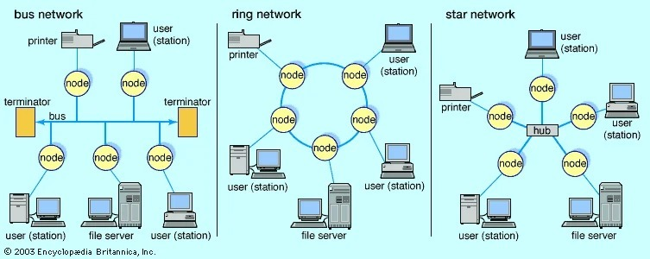

***EXAMPLE:-***

The notion of client-server architecture can be understood by the analogy of ordering a pizza for delivery. You call the store to order a pizza and someone picks up the call, takes your order, and then delivers it. Simple, right? Yes, this analogy pretty much answers the fundamental principle of client server architecture.

**4. What is role of compiler?**

🡺compiler, computer software that translates (compiles) source code written in a high-level language (e.g., C++) into a set of machine-language instructions that can be understood by a digital computer's CPU. Compilers are very large programs, with error-checking and other abilities.

**5. What is difference between Compiler and Interpreter?**

|  |  |
| --- | --- |
| ***Interpreter*** | ***Compiler*** |
| Translates program one statement at a time. | Scans the entire program and translates it as a whole into machine code. |
| Interpreters usually take less amount of time to analyze the source code. However, the overall execution time is comparatively slower than compilers. | Compilers usually take a large amount of time to analyze the source code. However, the overall execution time is comparatively faster than interpreters. |
|  |  |
| No Object Code is generated, hence are memory efficient. | Generates Object Code which further requires linking, hence requires more memory. |
| Programming languages like JavaScript, Python, Ruby use interpreters. | Programming languages like C, C++, Java use compilers. |

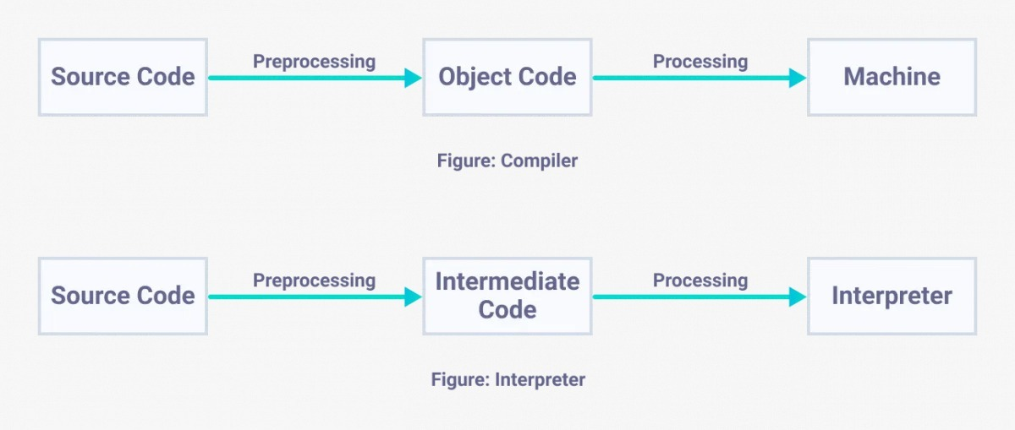

**6. What is MVC?**

🡺Model View Controller (MVC) is a framework for building web applications using a specified design. M stands for model. V stands for view. C stands for controller.

**7. What is communication protocol and what is difference between HTTP and HTTPS?**

1. ***What is communication protocol?***

🡺A communication protocol is a system of rules that allows two or more entities of a communications system to transmit information via any kind of variation of a physical quantity. The protocol defines the rules, syntax, semantics and synchronization of communication and possible error recovery methods. Protocols may be implemented by hardware, software, or a combination of both.

1. ***What is HTTP?***

🡺Full form of HTTP is Hypertext Transfer Protocol. HTTP offers set of rules and standards which govern how any information can be transmitted on the World Wide Web. HTTP provides standard rules for web browsers & servers to communicate.

1. ***What is HTTPS?***

🡺HTTPS stands for Hyper Text Transfer Protocol Secure. It is highly advanced and secure version of HTTP. It uses the port no. 443 for Data Communication. It allows the secure transactions by encrypting the entire communication with SSL. It is a combination of SSL/TLS protocol and HTTP. It provides encrypted and secure identification of a network server.

|  |  |  |
| --- | --- | --- |
| ***Parameter*** | ***HTTP*** | ***HTTPS*** |
| Protocol | It is hypertext transfer protocol. | It is hypertext transfer protocol with secure. |
| Security | It is less secure as the data can be vulnerable to hackers. | It is designed to prevent hackers from accessing critical information. It is secure against such attacks. |
| Port | It uses port 80 by default | It was use port 443 by default. |
| Starts with | HTTP URLs begin with http:// | HTTPs URLs begin with https:// |
| Used for | It’s a good fit for websites designed for information consumption like blogs. | If the website needs to collect the private information such as credit card number, then it is a more secure protocol. |
| Scrambling | HTTP does not scramble the data to be transmitted. That’s why there is a higher chance that transmitted information is available to hackers. | HTTPS scrambles the data before transmission. At the receiver end, it descrambles to recover the original data. Therefore, the transmitted information is secure which can’t be hacked. |
| Protocol | It operates at [TCP/IP](https://www.guru99.com/tcp-ip-model.html) level. | HTTPS does not have any separate protocol. It operates using HTTP but uses encrypted TLS/SSL connection. |
| Domain Name Validation | HTTP website do not need SSL. | HTTPS requires SSL certificate. |
| Data encryption | HTTP website doesn’t use encryption. | HTTPS websites use data encryption. |
| Search Ranking | HTTP does not improve search rankings. | HTTPS helps to improve search ranking. |
| Speed | Fast | Slower than HTTP |
| Vulnerability | Vulnerable to hackers | It Is highly secure as the data is encrypted before it is seen across a network. |

**8. What is .net?**

🡺Common Language Runtime (CLR) is a managed execution environment that is part of Microsoft’s .NET framework. CLR manages the execution of programs written in different supported languages.

🡺CLR transforms source code into a form of bytecode known as Common Intermediate Language (CIL). At run time, CLR handles the execution of the CIL code.

**9. What is CLR?**

🡺Common Language Runtime (CLR) is a managed execution environment that is part of Microsoft’s .NET framework. CLR manages the execution of programs written in different supported languages.

🡺CLR transforms source code into a form of bytecode known as Common Intermediate Language (CIL). At run time, CLR handles the execution of the CIL code.

**10. What is difference between CLS and CTS?**

|  |  |
| --- | --- |
| ***CTS*** | ***CLS*** |
| CTS stands for Common Type System | CLS stands for Common Language Specification |
| It is meant for declaring different data types, how they are managed in runtime with cross language integration, type safety with great performance execution | It is meant for language interoperability i.e program written in one language can communicate with any other language, having full advantages of all object oriented concepts such as Polymorphism, Inheritance etc. |
| CTS is a superset of CLS this means it does not support all types in CTS | CLS is a subset of CTS i.e. all languages will be supported here. |

**11. What is difference between Compiler and Interpreter?**

|  |  |
| --- | --- |
| ***Interpreter*** | ***Compiler*** |
| Translates program one statement at a time. | Scans the entire program and translates it as a whole into machine code. |
| Interpreters usually take less amount of time to analyze the source code. However, the overall execution time is comparatively slower than compilers. | Compilers usually take a large amount of time to analyze the source code. However, the overall execution time is comparatively faster than interpreters. |
|  |  |
| No Object Code is generated, hence are memory efficient. | Generates Object Code which further requires linking, hence requires more memory. |
| Programming languages like JavaScript, Python, Ruby use interpreters. | Programming languages like C, C++, Java use compilers. |



**12. What is communication protocol and what is difference between HTTP and HTTPS?**

***1) What is communication protocol?***

🡺A communication protocol is a system of rules that allows two or more entities of a communications system to transmit information via any kind of variation of a physical quantity. The protocol defines the rules, syntax, semantics and synchronization of communication and possible error recovery methods. Protocols may be implemented by hardware, software, or a combination of both.

***2) What is HTTP?***

🡺Full form of HTTP is Hypertext Transfer Protocol. HTTP offers set of rules and standards which govern how any information can be transmitted on the World Wide Web. HTTP provides standard rules for web browsers & servers to communicate.

1. ***What is HTTPS?***

🡺HTTPS stands for Hyper Text Transfer Protocol Secure. It is highly advanced and secure version of HTTP. It uses the port no. 443 for Data Communication. It allows the secure transactions by encrypting the entire communication with SSL. It is a combination of SSL/TLS protocol and HTTP. It provides encrypted and secure identification of a network server.

|  |  |  |
| --- | --- | --- |
| ***Parameter*** | ***HTTP*** | ***HTTPS*** |
| Protocol | It is hypertext transfer protocol. | It is hypertext transfer protocol with secure. |
| Security | It is less secure as the data can be vulnerable to hackers. | It is designed to prevent hackers from accessing critical information. It is secure against such attacks. |
| Port | It uses port 80 by default | It was use port 443 by default. |
| Starts with | HTTP URLs begin with http:// | HTTPs URLs begin with https:// |
| Used for | It’s a good fit for websites designed for information consumption like blogs. | If the website needs to collect the private information such as credit card number, then it is a more secure protocol. |
| Scrambling | HTTP does not scramble the data to be transmitted. That’s why there is a higher chance that transmitted information is available to hackers. | HTTPS scrambles the data before transmission. At the receiver end, it descrambles to recover the original data. Therefore, the transmitted information is secure which can’t be hacked. |
| Protocol | It operates at [TCP/IP](https://www.guru99.com/tcp-ip-model.html) level. | HTTPS does not have any separate protocol. It operates using HTTP but uses encrypted TLS/SSL connection. |
| Domain Name Validation | HTTP website do not need SSL. | HTTPS requires SSL certificate. |
| Data encryption | HTTP website doesn’t use encryption. | HTTPS websites use data encryption. |
| Search Ranking | HTTP does not improve search rankings. | HTTPS helps to improve search ranking. |
| Speed | Fast | Slower than HTTP |
| Vulnerability | Vulnerable to hackers | It Is highly secure as the data is encrypted before it is seen across a network. |

**13. What do you mean by design pattern?**

🡺A design pattern is a repeatable solution to a software engineering problem. Unlike most program-specific solutions, design patterns are used in many programs. Design patterns are not considered finished product; rather, they are templates that can be applied to multiple situations and can be improved over time, making a very robust software engineering tool. Because development speed is increased when using a proven prototype, developers using design pattern templates can improve coding efficiency and final product readability.

**14. What is client server architecture?**

🡺architecture of a computer network in which many clients (remote processors) request and receive service from a centralized server (host computer). Client computers provide an interface to allow a computer user to request services of the server and to display the results the server returns.



***EXAMPLE:-***

The notion of client-server architecture can be understood by the analogy of ordering a pizza for delivery. You call the store to order a pizza and someone picks up the call, takes your order, and then delivers it. Simple, right? Yes, this analogy pretty much answers the fundamental principle of client server architecture.

**15. What is difference between Asp.Net and MVC.Net?**

|  |  |
| --- | --- |
| ***ASP.NET*** | ***ASP.NET MVC*** |
| Inbuilt Server Controls | Test-Driven Development & Re-Usability |
| Viewstate Support | Improved Performance |
| Event-Driven Programming | Increased control Over HTML |
| Rapid Application Development | Extensibility |

🡺ASP.NET is a web platform. It provides a layer that sits on top of IIS (the web server) which facilitates the creation of web applications and web services. ASP.NET MVC is a framework specifically for building web applications. It sits ontop of ASP.NET and uses APIs provided by ASP.NET.